**Reading and writing csv files with python:**

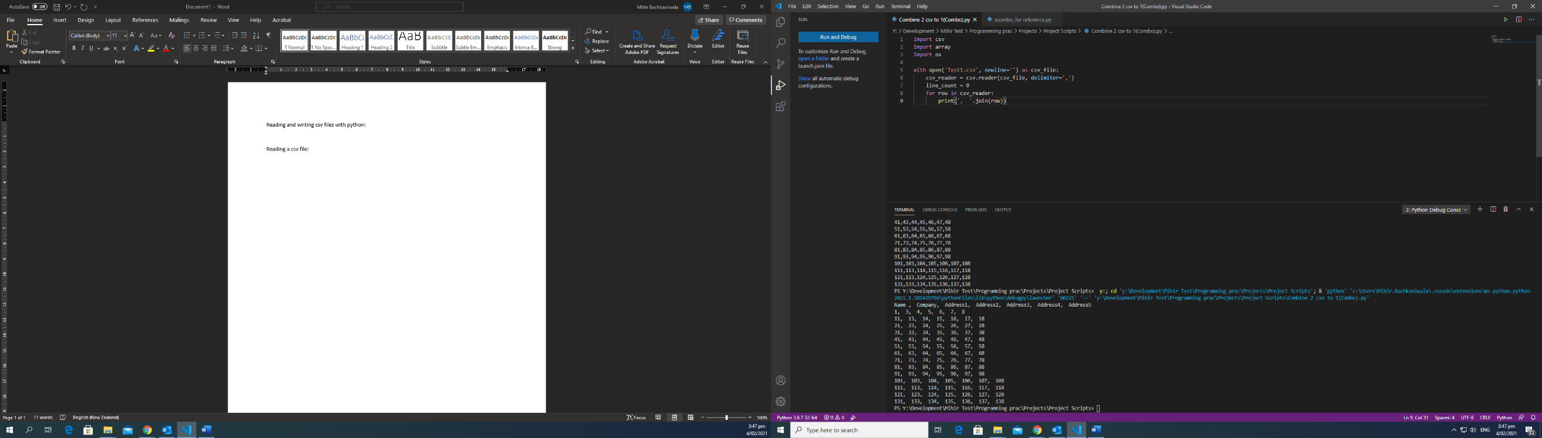**Reading a csv file:**

with open('Test3.csv', newline='') as csv_file:

csv_reader = csv.reader(csv_file, delimiter=',')

line_count = 0

for row in csv_reader:

print(', '.join(row))

**Write to a new file:**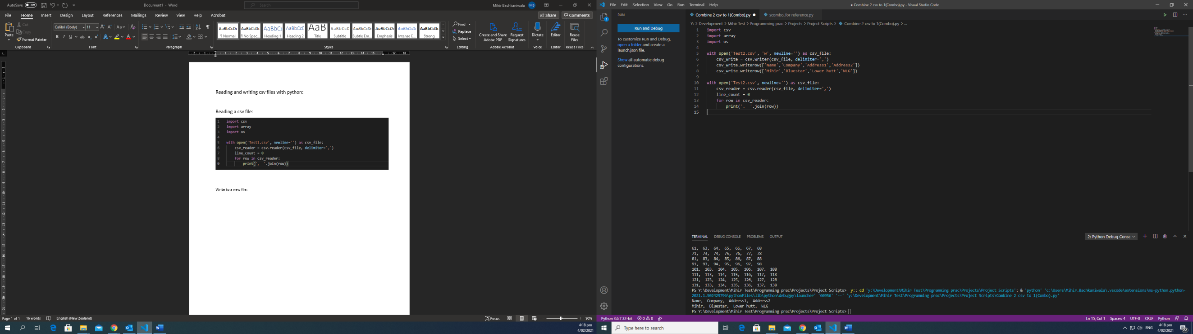

Creates new file Test2.csv, writes stuff in it and reads from it.

with open('Test3.csv', 'w', newline='') as csv_file:

csv_write = csv.writer(csv_file, delimiter=',')

csv_write.writerow(['Name','Company','Address1','Address2'])

csv_write.writerow(['Mihir','Bluestar','Lower hutt','WLG'])

with open('Test3.csv', newline='') as csv_file:

csv_reader = csv.reader(csv_file, delimiter=',')

line_count = 0

for row in csv_reader:

print(', '.join(row))

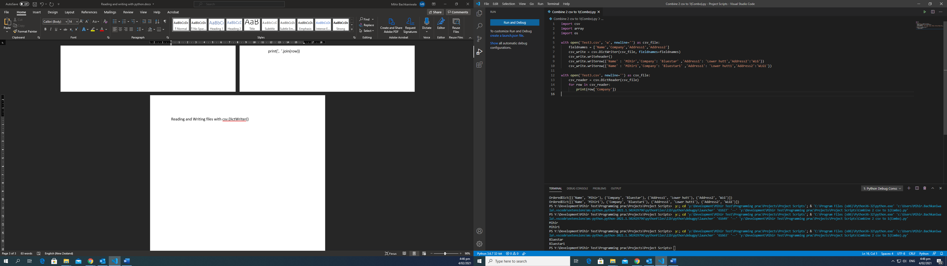Reading and Writing files with csv.DictWriter()

with open('Test3.csv', 'w', newline='') as csv_file:

fieldnames = ['Name','Company','Address1','Address2']

csv_write = csv.DictWriter(csv_file, fieldnames=fieldnames)

csv_write.writeheader()

csv_write.writerow({'Name' : 'Mihir','Company': 'Bluestar' ,'Address1': 'Lower hutt','Address2':'WLG'})

csv_write.writerow({'Name' : 'Mihir1','Company': 'Bluestar1' ,'Address1': 'Lower hutt1','Address2':'WLG1'})

with open('Test3.csv', newline='') as csv_file:

csv_reader = csv.DictReader(csv_file)

for row in csv_reader:

print(row['Company'])

Copy data from 1 file to another:

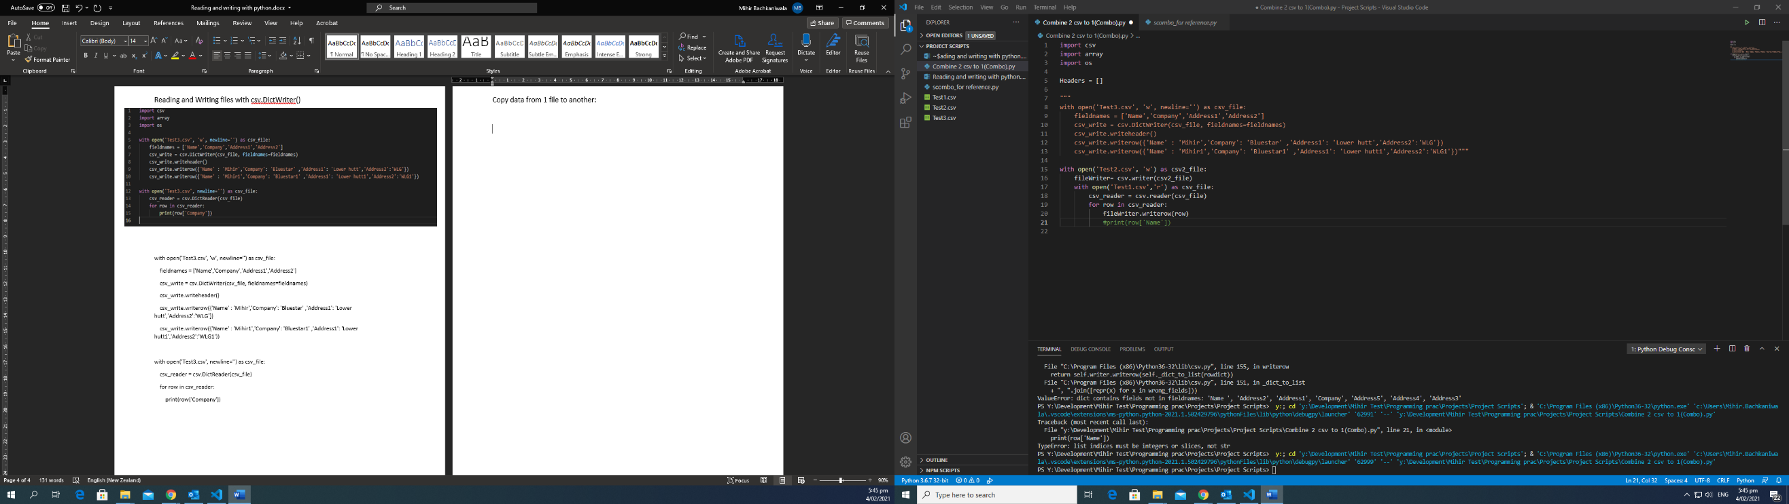

with open('Test2.csv', 'w') as csv2_file:

fileWriter= csv.writer(csv2_file)

with open('Test1.csv','r') as csv_file:

csv_reader = csv.reader(csv_file)

for row in csv_reader:

fileWriter.writerow(row)

#print(row['Name'])